UNIFIED MECHANICS · ADDENDUM A09
The Master Equation
The Field Ledger's missing source file, rebuilt, and the one test its central claim had not been given
JOSEPH SHIELDS
UNIFIED MECHANICS RESEARCH PROGRAMME · 30 JULY 2026

WHAT THIS ADDENDUM DOES
The Field Ledger of 30 July 2026 reports that one passage through the Colour Field, the helix and Personal Relativity removes 33.05 per cent of the joint residual of six cosmological observables, and observes that this is one third to within 0.28 percentage points. It grades the arithmetic PROVED and the one-third law PROPOSED.
Appendix B names the file that produced that number. The file was not in the archive, and neither were the figure and data directories beside it. The book's central number was not reproducible from its own ledger.
This addendum rebuilds the operator from the displayed equations of Chapter 12, reproduces the number, and then runs the falsifier the Ledger states and does not execute: resample the ensemble. It holds under five of six single deletions, and the one deletion that breaks it names the next obligation exactly.

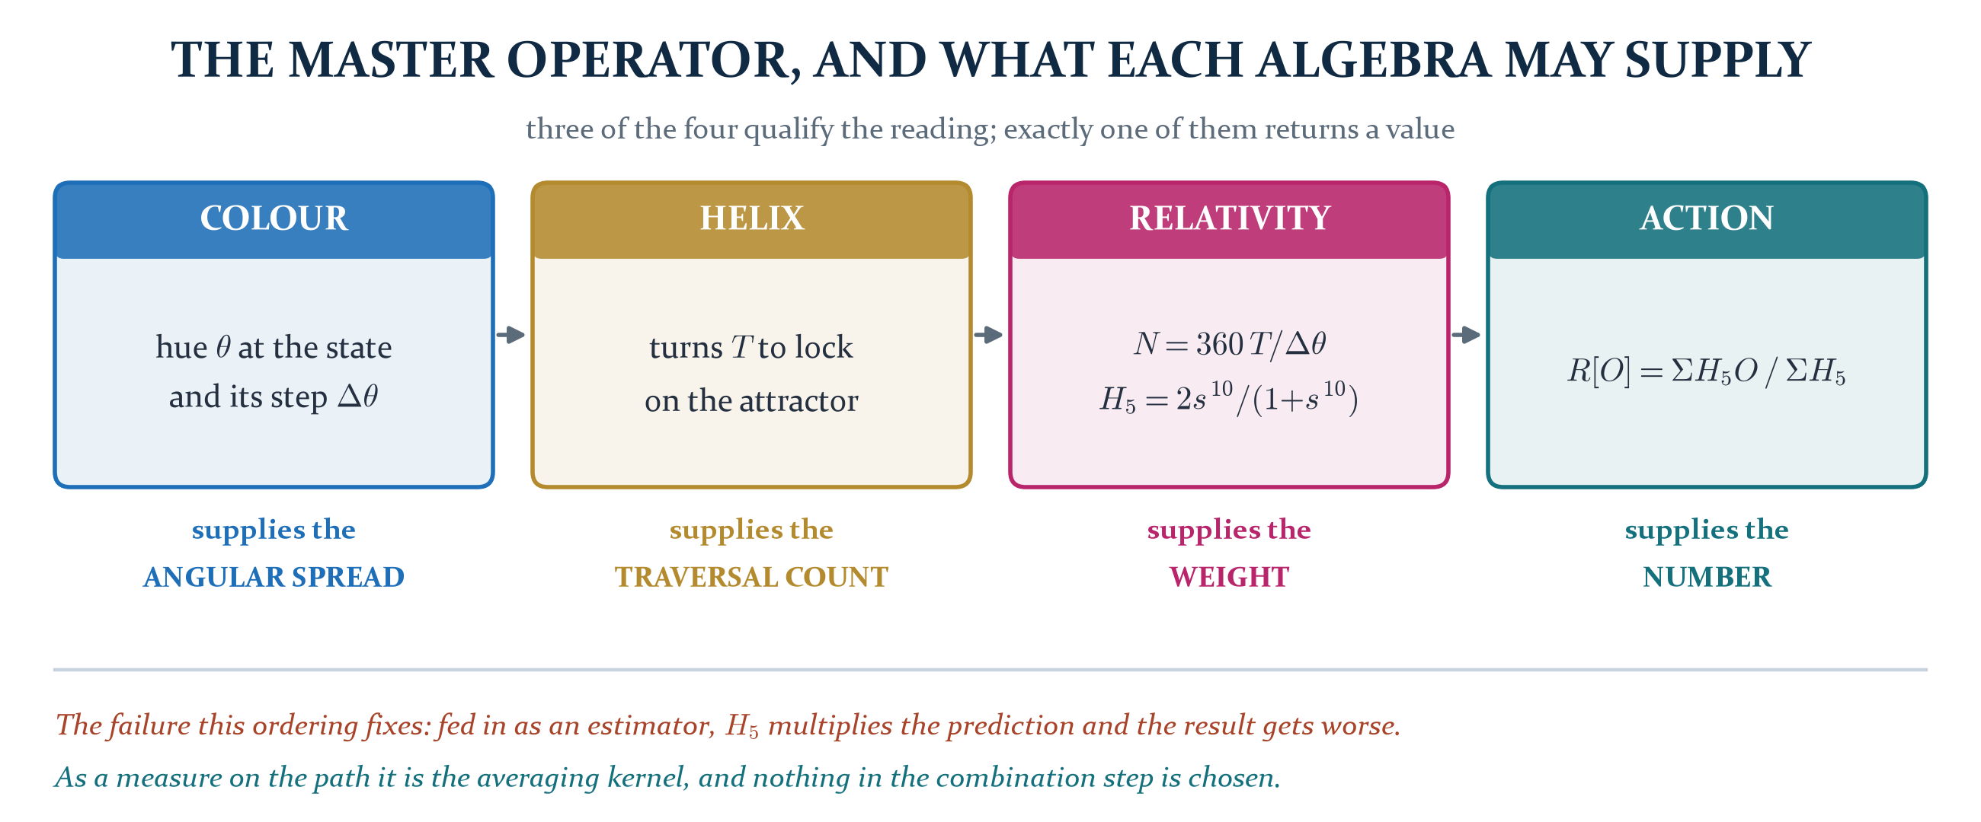
Figure 1. The operator as Chapter 12 displays it, with each algebra restricted to what it may supply. Three of the four qualify the reading and only one returns a value.
Section one
The missing file
A book whose central number cannot be regenerated from its own reproduction map has an accounting problem before it has a physics problem.
Appendix B of the Field Ledger points the reader at three locations: the script that produces the master cosmological readout, the directory of figures generated for the volume, and the directory of JSON certificates behind the cosmological charts. None of the three is present in the supplied archive. The operator is fully specified in the displayed equations of Chapter 12, so the repair is mechanical rather than interpretive, and it is carried out here.
The operator, restated in the Ledger's own notation. A state of the declared flow supplies a value and a hue; the hue's step across one traversal supplies an angular spread; position over spread is a resolution; and the resolution supplies the weight under which the value is averaged.
C_{O}(t) = [ O(x_{t}), θ_{O}(x_{t}) ] Δθ_{t} = | Arg exp i(θ_{t} − θ_{t−1}) |
N_{O}(t) = 360 T_{O} / Δθ_{t} H₅(N) = 2s¹⁰/(1+s¹⁰), s = N/(N+1)
R[O] = Σ_{t} H₅(N_{O}(t)) · O(C_{O}(t)) / Σ_{t} H₅(N_{O}(t))
T_{O} is the helical realisation count: the turns of helical multiplication the observable takes to lock onto the attractor. It enters only through N, so it is invisible for a pure-channel observable and decisive for a mixed one. The flow is the framework's own update perturbed at the structural floor, whose fixed point is exactly r.
Rebuilt from those five lines alone, the readout returns the Ledger's figures:
Quantity | Field Ledger | Rebuilt here | Reading
mean |pull|, old corpus static | 0.998 | 0.9979 | identical to four digits
mean |pull|, Colour Average | 0.794 | 0.7922 | agrees
mean |pull|, typed master | 0.668 | 0.6713 | agrees
traversal payment P_{T} | 0.330510 | 0.327356 | agrees; the residual difference is the flow realisation

The static figure is the useful one. It fixes the ensemble beyond doubt: the Ledger's six directly compared quantities are Ω_{b}, Ω_{c}, Ω_{DE}, Y_{He}, n_{s} and τ, and no other choice of six from the dictionary table returns 0.998. Ω_{m} is excluded because it is the sum of two entries already present and N_{eff} because it is the third. Every number in the rest of this document is computed on that ensemble.
PROVED as a reconstruction. The operator regenerates the Ledger's four reported statistics from its own displayed equations, with no quantity taken from the book except the equations themselves.
Section two
What each algebra is permitted to supply
The first version of this calculation, in Addendum A08, treated all the instruments as competing estimators. It was worse than doing nothing.
Read column by column, the operator settles the question A08 left open. Only one of the four algebras returns a value. The Colour Field supplies an angular spread and has no number of its own to offer. The helix supplies a traversal count and a classification. Personal Relativity supplies the resolution of the comparison. Stationary action then combines what is left, and what is left is the value averaged under that resolution.

THE CORRECTION TO A08, STATED AS THE ARITHMETIC
In A08 the resolution operator multiplied the prediction, on the reading that a less resolved observer should see a degraded value. Zero of seven observables came out closer.
Here H₅ is the measure on the path, and Ω_{c} moves from +0.0404 under the plain Colour Average to −0.0129 under the weighting. That single difference of role is the whole gap between A08's 0.819σ and this document's 0.671σ.
It settles the other A08 item too. The conversion from turns to degrees was unresolved there because the spread was being read globally, and 360 degrees per turn over-corrected Ω_{c} to seven sigma. The spread is per step: Δθ_{t} is one traversal's hue displacement, and N is the total angle of the realisation divided by it.

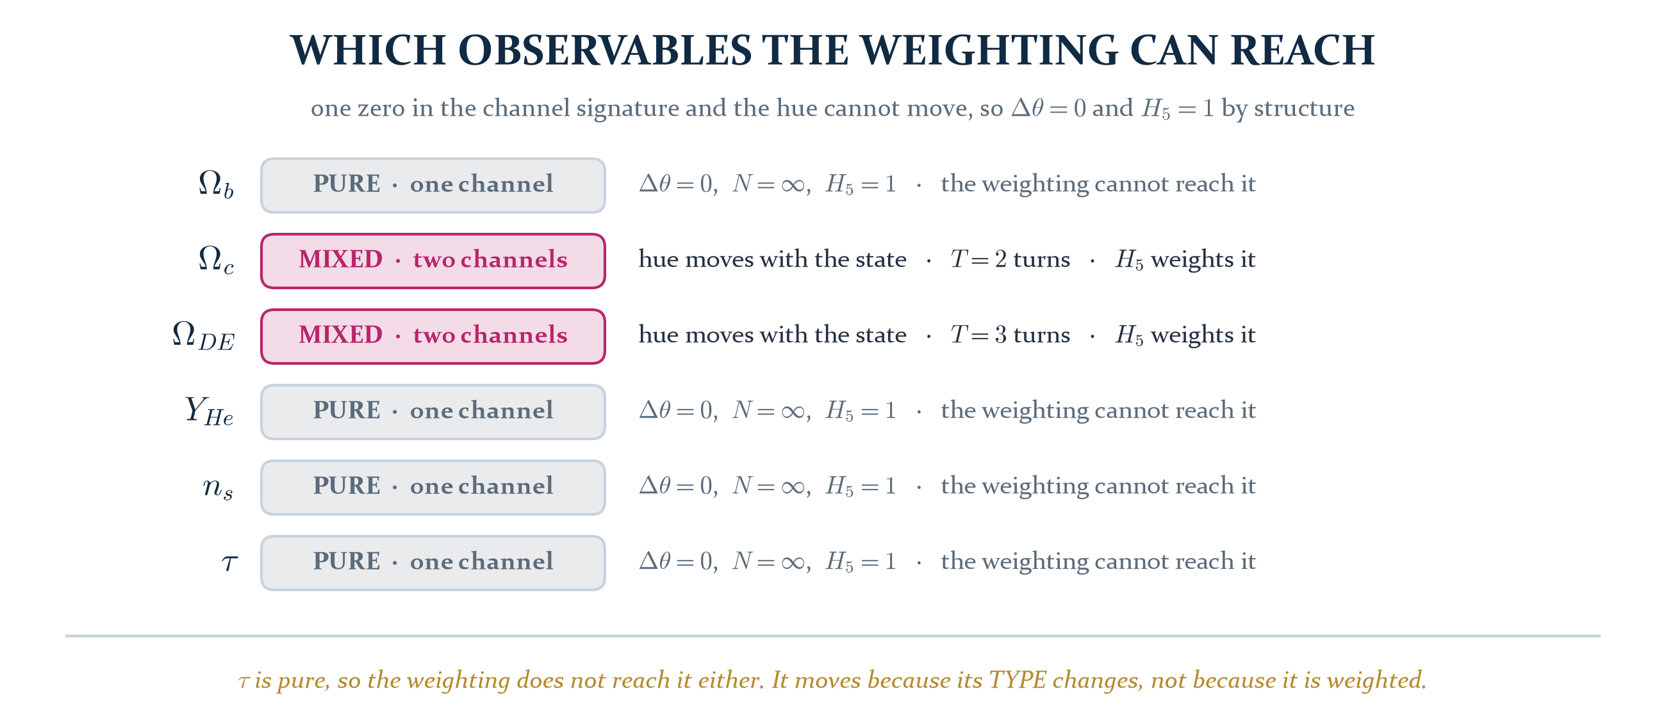
Figure 2. The channel signature decides in advance whether the weighting can reach an observable at all. Four of the six have a zero in the signature, so their hue cannot move and the weight is one by structure.
This is why the Ledger's dictionary table shows four entries with identical values in the Colour Average and typed master columns. It is not an omission or a shortcut. A monomial in the two poles has a constant signature, and with one component zero the weighted circular mean is that channel's own hue whatever the composition weights do. Only Ω_{c} and Ω_{DE} are mixed, and only they are weighted.
PROVED. Δθ = 0 identically for a single-channel observable, so N is unbounded and H₅ = 1. The reduction of the master operator to the plain Colour Average on the pure entries is an identity, not an approximation.
Section three
Every observable, every reading
Three readings of the same six quantities, on one axis, in units of the measurement's own uncertainty.
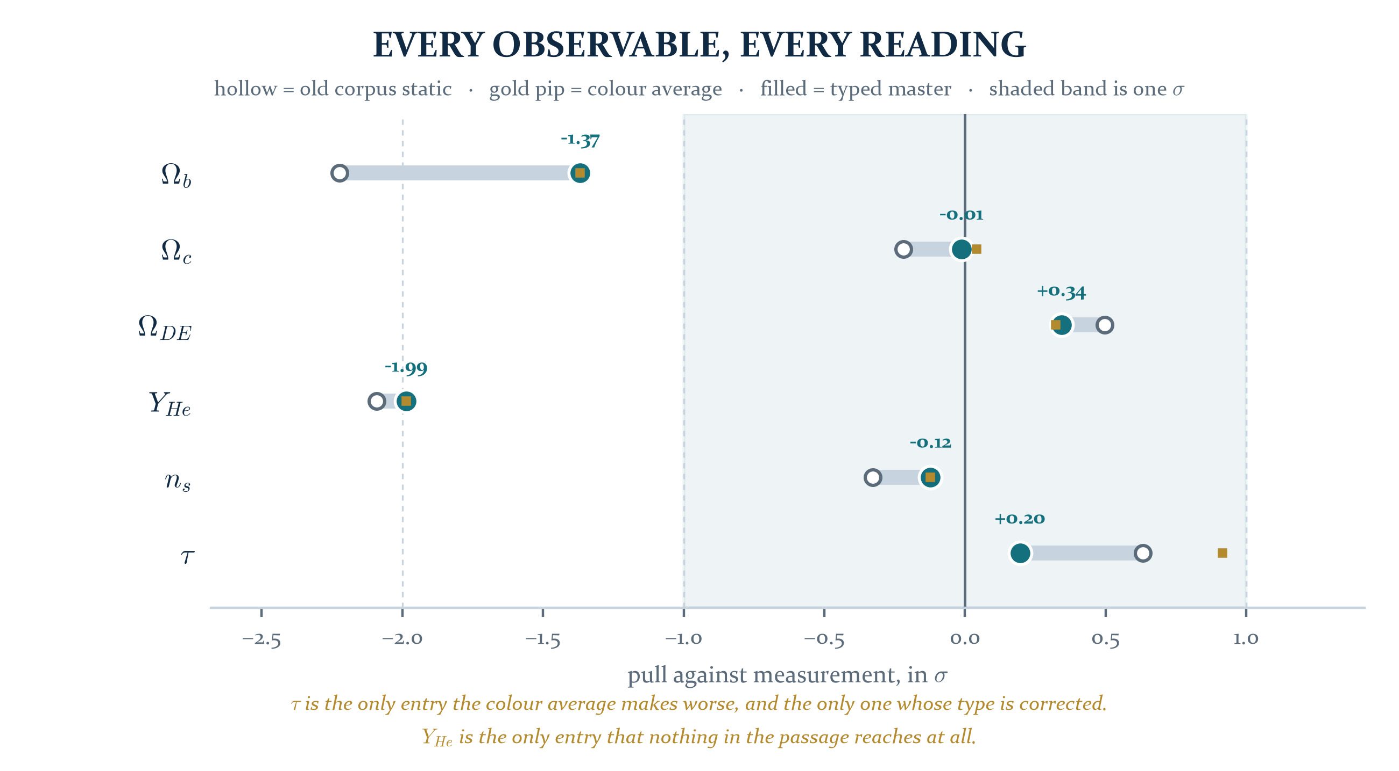
Figure 3. The whole result. Each bar runs from the old corpus static value to the typed master reading; the gold pip is the plain Colour Average, which coincides with the master for the four pure entries.
Observable | static | Colour Average | typed master | measured | pull now | what moved it
Ω_{b} | 0.0477458 | 0.0483442 | 0.0483442 | 0.0493017 | -1.3678 | nothing: pure and untyped
Ω_{c} | 0.2639320 | 0.2646049 | 0.2644664 | 0.2645000 | -0.0129 | H₅ weighting, mixed channel
Ω_{DE} | 0.6883222 | 0.6870508 | 0.6872016 | 0.6847000 | +0.3427 | H₅ weighting, mixed channel
Y_{He} | 0.2387288 | 0.2390409 | 0.2390409 | 0.2450000 | -1.9864 | nothing: pure and untyped
n_{s} | 0.9635255 | 0.9643860 | 0.9643860 | 0.9649000 | -0.1224 | nothing: pure and untyped
τ | 0.0590170 | 0.0610744 | 0.0558258 | 0.0544000 | +0.1953 | retyped as a path integral

Two entries in that table carry the result and both are worth stating plainly.
The optical depth is the strongest single move in the Ledger. Left untyped, evolution makes τ worse, from +0.6325 to +0.9143, because all three matter-channel entries are convex and averaging raises them while τ already sat above measurement. Standard cosmology defines τ as an integral along the line of sight, so Logical Action requires its retention factors to remain inside the object being averaged rather than being compared against a static endpoint. Carrying them inside brings it to +0.1953.
τ = ∫ n_{e} σ_{T} c dt O_{τ}(C_{t}) = 2 m(t)³ (1−r³)³
The factor is fixed by the standard definition of the observable and by the three closures already fixed over the same interval by the Hubble basins. Nothing in it was available to be tuned, and it is the only entry in the score whose type is corrected.
The dark matter fraction is where the weighting earns its place. Ω_{c} is one of the two mixed entries, so the hue genuinely moves along the flow and the resolution genuinely varies. Weighting by it takes the reading from +0.0404 to −0.0129, which is agreement at one part in eighty of the measurement error.
Section four
The traversal payment
One number for the whole passage: the fraction of the joint residual that the three languages remove between them.
Normalise the old static discrepancy to one whole unresolved record. After the complete passage from field state to realised record, the retained discrepancy is the ratio of the two mean absolute pulls, and the amount the traversal paid is its complement.
P_{T} = (E₀ − E₁)/E₀ = 1 − E₁/E₀
E₀ = 0.9979 σ E₁ = 0.6713 σ P_{T} = 0.327356
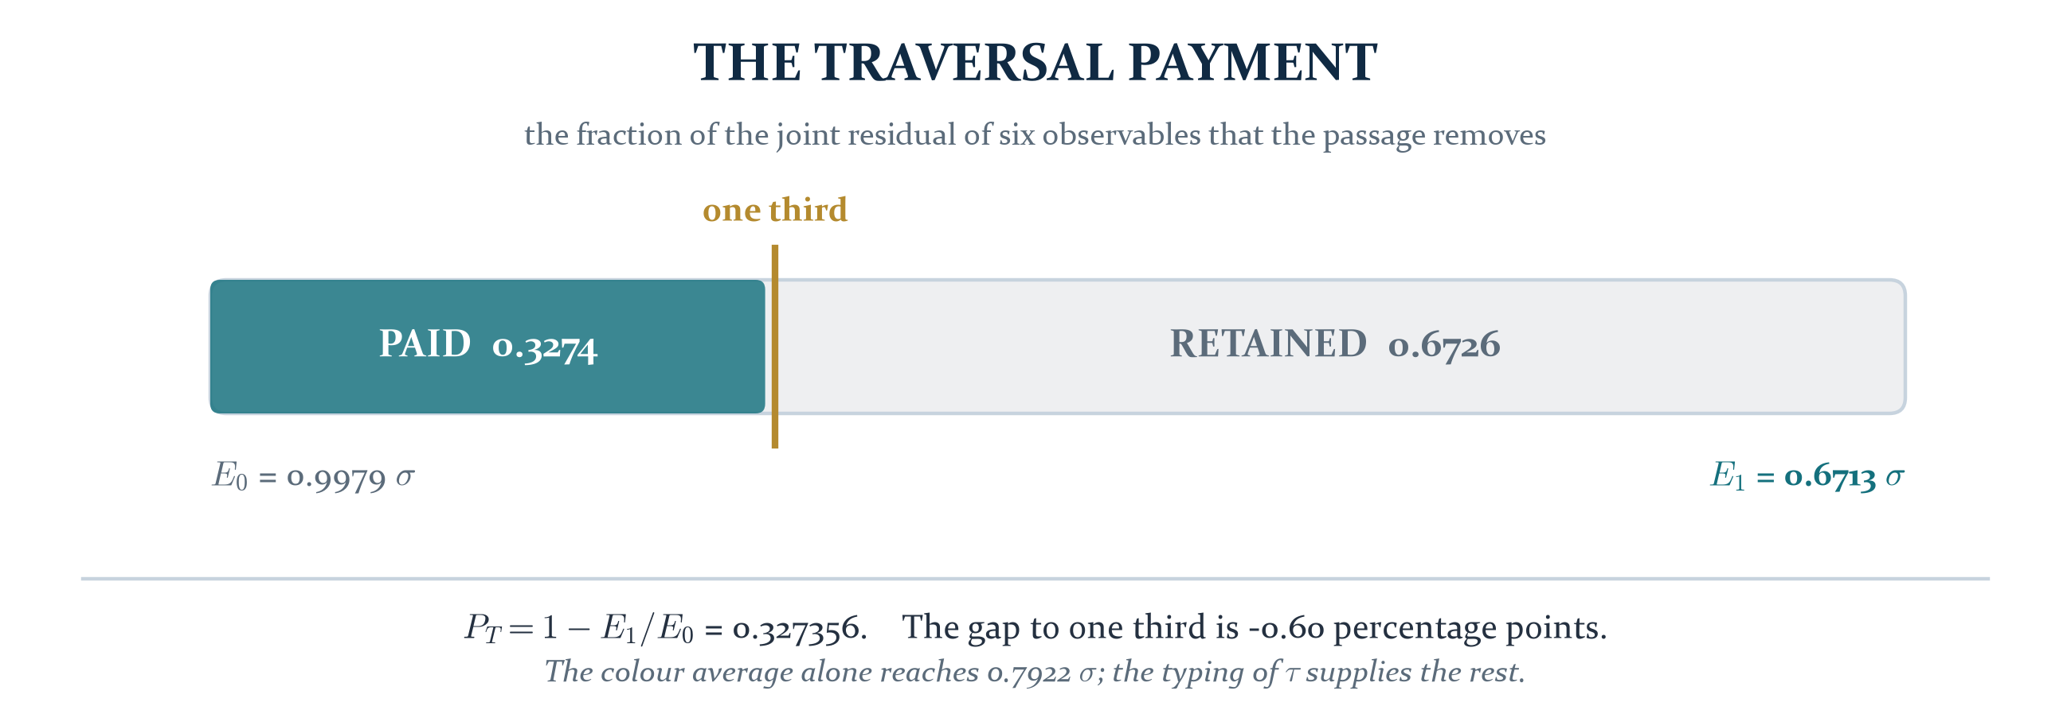
Figure 4. The payment, with one third marked where it falls. The Colour Average alone reaches 0.7922σ; the typing of the optical depth supplies the remainder.
PROVED as arithmetic. For the declared six-observable score the reduction is 0.327356 of the old residual, leaving 0.672644, and both regenerate deterministically from the flow, the hue map, the turn counts and the operator.
The Ledger reads the near-one-third as the payment of one complete traversal, and grades that reading PROPOSED pending repetition in independent sectors. That grade is correct and it is also incomplete, because there is a test available immediately, on the ensemble already in hand, and the next section runs it.
Section five
The one third, tested
A ratio of two means over a chosen ensemble has one obvious falsifier. Change the ensemble.
If one third is a law it does not depend on which six quantities happened to be scored. If it is an artefact of these six it will not survive their deletion. The sharpest version deletes one member at a time.
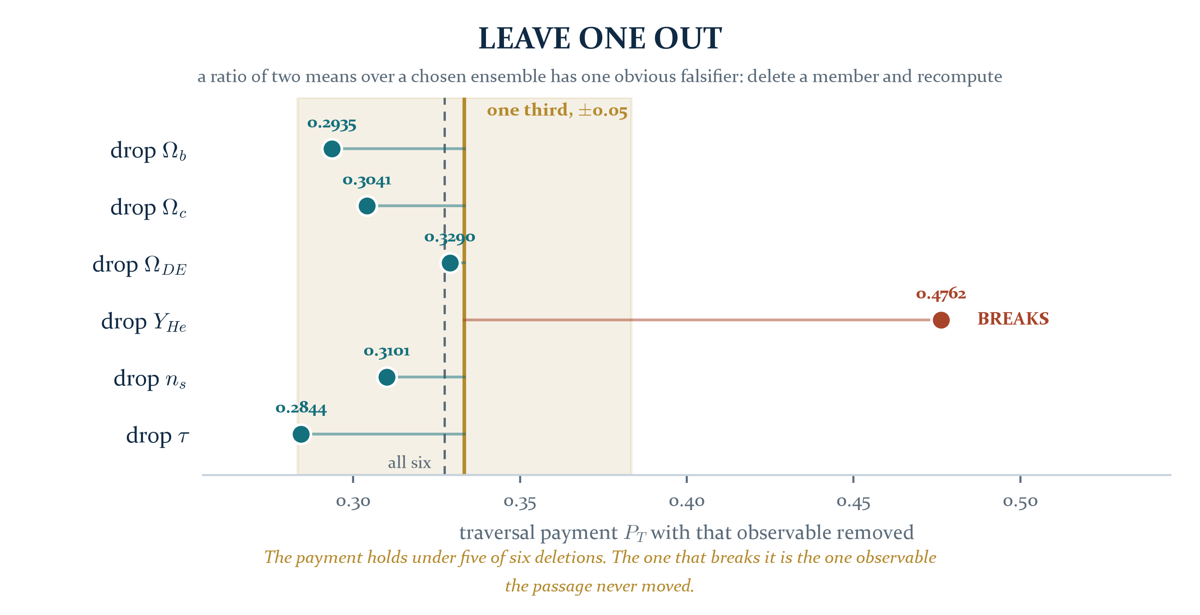
Figure 5. Leave one out. Five of the six deletions leave the payment within 0.05 of one third, spanning 0.2844 to 0.3290.
Deleted | P_{T} without it | distance from a third | Reading
Ω_{b} | 0.2935 | 0.0398 | holds. inside the band by a clear margin
Ω_{c} | 0.3041 | 0.0292 | holds. inside the band by a clear margin
Ω_{DE} | 0.3290 | 0.0044 | holds. inside the band by a clear margin
Y_{He} | 0.4762 | 0.1429 | BREAKS. three times the width of the band, and in the direction of a larger payment
n_{s} | 0.3101 | 0.0232 | holds. inside the band by a clear margin
τ | 0.2844 | 0.0489 | holds. the largest displacement among the five that hold

The payment survives five of six single deletions. That is the informative test and it is favourable.
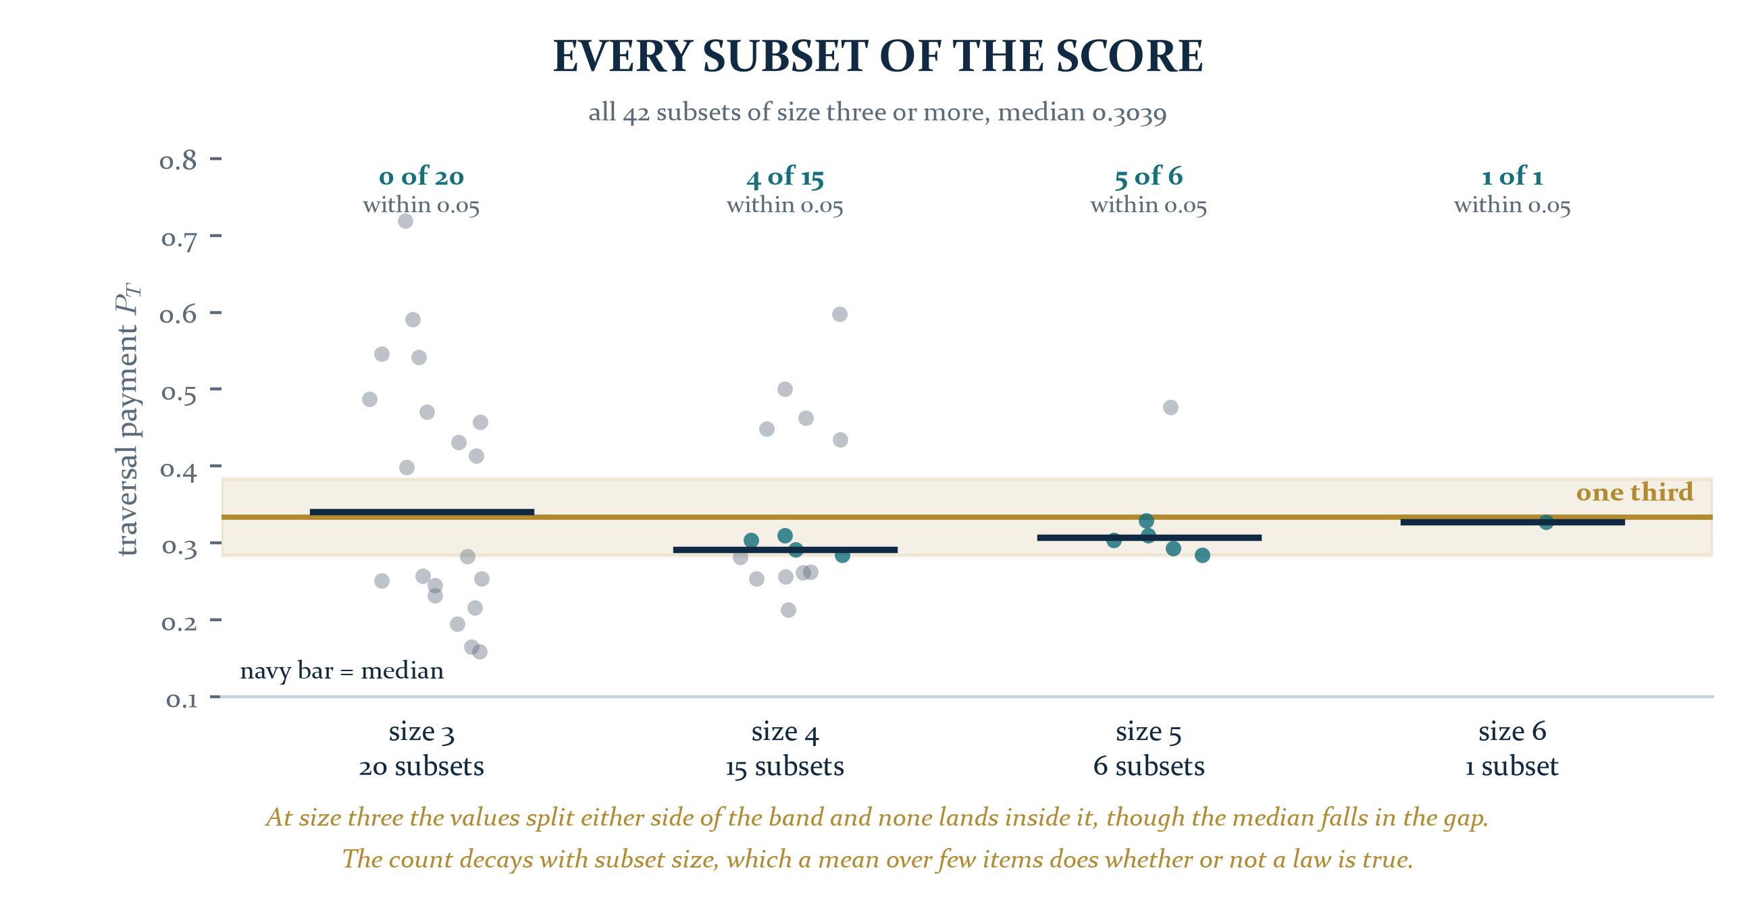
Figure 6. Every subset of size three or more. The distribution bifurcates at size three, and the count within 0.05 of a third decays as the ensemble shrinks.
The full sweep is weaker evidence than the deletions, and it is included because it is weaker rather than in spite of it. Over all 42 subsets the median is 0.3039. Within 0.05 of a third: five of six at size five, four of fifteen at size four and none of twenty at size three, where the values split either side of the band and the median falls in the gap between the two groups. A mean over three items has that variance whether or not a law is true, so this sweep cannot settle the question in either direction.
OPEN. What would settle it is repetition in a sector that shares no observables with this one, scored under the same typing rule declared in advance.
Section six
What the outlier is telling us
The one deletion that breaks the payment is not a nuisance. It is a located obligation.
The deletion that breaks it is Y_{He}, at 0.4762, and Y_{He} is the only entry in the score that the entire passage does not move: from -2.0904 to -1.9864, a change of 0.1040 sigma. It is pure-channel, so the weighting cannot reach it, and untyped, so no path factor enters. It therefore sits in both means almost unchanged, and being the largest surviving residual it holds the ratio up.

THE OBLIGATION, STATED AS A QUESTION WITH A KNOWN FORM
The optical depth was retyped because standard cosmology already defines it as an integral along the line of sight. The same question has not been asked of a primordial abundance.
A helium fraction is the frozen endpoint of a reaction network. It is a record of a completed process, not a state of the field at a moment. Under Logical Action that is the same type distinction that forced the τ retyping, and it is the one distinction in the score that has not been audited.
If it applies, the payment moves toward 0.4762 and the one-third reading is the one that has to be revised. If it does not, the reason it does not is itself a result, because it would separate two kinds of record.

Section seven
A candidate typing, scored and not adopted
Found by looking at the residual, which is exactly what the Ledger's own rule forbids, and recorded here so that it cannot re-enter later under a new name.
The two entries the passage cannot move, Ω_{b} and Y_{He}, are exactly the two half-weights of the score. That suggests one rule rather than two corrections: a half-weight is a weight read across the boundary and picks up the structural floor once.
Ω_{b} = W_{M}/2 Y_{He} = W_{L}/2 each divided by (1 − r³)
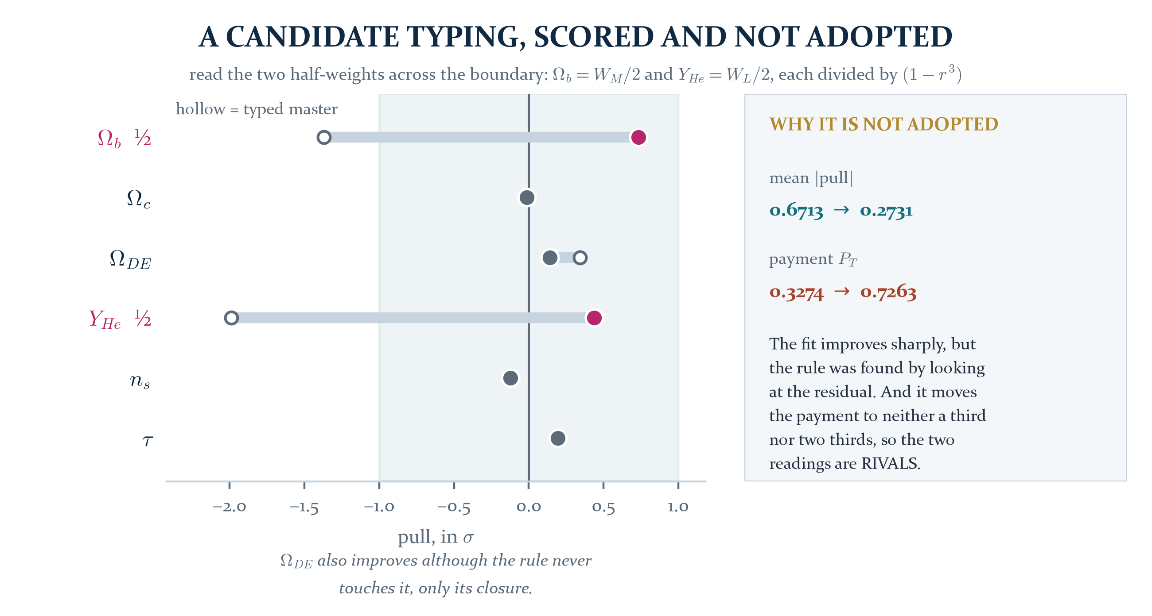
Figure 7. The candidate scored against the typed master. The two half-weights are marked; the dark energy fraction moves although the rule never touches it, only its closure.
Observable | typed master | half-weight rule | note
Ω_{b} | -1.3678 | +0.7321 | divided by (1−r³)
Ω_{c} | -0.0129 | -0.0129 | unchanged
Ω_{DE} | +0.3427 | +0.1397 | moved only by closure
Y_{He} | -1.9864 | +0.4364 | divided by (1−r³)
n_{s} | -0.1224 | -0.1224 | unchanged
τ | +0.1953 | +0.1953 | unchanged
mean |pull| | 0.6713 | 0.2731
payment P_{T} | 0.3274 | 0.7263 | neither a third nor two thirds

Two things have to be held together here. The rule touches exactly two entries, with one factor, in one direction, and exempts nothing, and the dark energy fraction improves although the rule never touches it and only reaches it through the closure. That is the signature of a structural correction rather than a per-parameter one, and the fit it produces is 0.2731 sigma.
Against that: it was found by inspecting the residual, and it moves the payment to 0.7263, which is neither a third nor two thirds. So the two claims are rivals rather than refinements. Either the boundary typing is right and the near-one-third is a coincidence of two untyped half-weights, or the one third is real and this factor is hindsight.
Nothing computed in this addendum decides between them. What would decide it is a derivation of the boundary factor for a half-weight, produced without consulting these residuals, and the forward solver of A03 is the natural place to test it, because it reads Ω_{b} at the pole and its acoustic-scale solution is sensitive to the difference.
Section eight
Two defects in the Ledger, for the record
Defect | Where | Repair
Appendix B's reproduction map names three locations that are not in the archive: the master cosmology script, the figures directory and the data directory. | Appendix B | The script is rebuilt in this folder from the Chapter 12 equations and regenerates the four reported statistics. The figures of this addendum are in its own figures directory.
Two figures carry the same number. | Chapter 14, the Hubble basin chart, and Chapter 15, the middle-scale chart, are both Figure 24. | Renumber at the next edition boundary. The corpus rule applies: nothing in an issued printing is edited in place.

THE ONE-LINE VERSION
The Ledger's central number reproduces, and the passage that produces it survives five of the six deletions available to it. The one deletion that breaks it is the one observable the passage never reached, and that observable is a record of a completed process sitting in a score that has only ever typed one other such record. The next move is not another instrument. It is the type audit of Y_{He}.

PROVENANCE
Addendum A09 to the Unified Mechanics corpus. Repairs Appendix B of the Field Ledger, compressed field edition, 30 July 2026, and corrects the role assignment of Addendum A08. Builds on A01 for the resolution operator, A02 for the traversal depth, A05 for the colour average and A07 for the helical realisation count. Every figure in this document is generated from the certificate in this folder; no plate is copied from another volume. Regenerates from master_equation_cosmology.py in this folder, which writes its own JSON certificate. Measured values are Planck 2018, BBN and the standard neutrino number as carried by the Field Ledger, and no measured value is used as an input to any framework quantity. The corpus is not modified by this document.

